Lewis University  
CPSC 50900: Database Systems  
Term Project

TITLE OF YOUR PROJECT

Online Jewellery Shop

Prudhvi venigalla

[prudhvikrishnaveni@lewisu.edu](mailto:prudhvikrishnaveni@lewisu.edu)

Akshith Paspula

akshithpaspula@lewisu.edu

Work products stored in the Github repository PUT GITHUB URL HERE

Table of Contents

Initial Proposal 2

Data Sources 2

Data Storage Alternatives 2

Relational Database Design Process 3

Relational Database Design 3

Data Definition Language (DDL) Scripts 3

Data Manipulation Language Scripts 4

Indexes 5

Views 5

Triggers 5

Transactions 5

Database Security 6

Locking and Concurrent Access 6

Backing Up Your Database 6

Python Programming 7

PHP Programming 7

Suggested Future Work 8

Activity Log 8

Initial Proposal

*Description: You will describe the data you aim to store. What data will be storing? Why are you interested in this data? Why is it important? Where will the data come from? Who will use this data? What kind of application do you plan to build with it?*

*Rubric: Your response to each of these six questions will be graded out of 3 points.*

*3 points: clear, complete descriptions that convey the importance and meaning of your data*

*2 points: mostly clear descriptions, although some additional data would have helped in some sections*

*1 point: necessary details are lacking in many of your responses.*

*You will also earn 2 additional points for coming up with a descriptive title for your project.*

*Total points possible: 20*

Project Title

Online Jewelry Shop

Initial Proposal

Jewelry is sorted in two divisions, the contemporary, meaning modern and fashionable at present time, and then the traditional, which represents something important which occurred in a specific date or time of the year. By traditional can also mean a piece of jewelry symbolizing the country. Each of this characteristics show attractiveness and eye catching designs. Both demonstrate jewelry as a form of precious gem stones, gold, silver, other metals and natural materials.

The primary objective of wearing jewelry as pieces of decoration are to look beautiful and jewelry has been related with women for their personal beautification. The beginning of this tradition started back in ancient times when beads and shells were used as body ornaments, while bones, wood, elephant tusk and decorative stones were carved to produce attractive artifacts.

They had common tradition choices from useful utility like pinning clothes or were symbols and decorated the person from head to toe. However, nowadays the higher claim for jewelry pieces has made craftsmen more creative. Stunning items in gold, silver, platinum and gem stones have inundated the market in variety of styles and designs. The major items include necklaces, amulets, bangles, bracelets, earrings, nose ring, and anklets.

The main objectives of this project are:

1. Save time
2. Provide facilities to the Costumers
3. Provide an easy way to search for latest Jewellery
4. Contact the Seller Directly

TER YOUR INITIAL PROPOSAL HERE

Data Sources

*Description:* *Gather your data in text files. The text files may be csv, tab-delimited, xml, json, or some other custom format. Not all the files need be of the same type. Identify what each file contains by indicating where it came from, explaining in detail how it structured, and describing how you will reorganize the data into a relational database. Post your data files to your GitHub repository, and provide samples of the data in your Word doc.*

*Rubric: Your work will be graded as follows:*

*5 points: you gathered multiple data files that contain the data that will populate your databases. If you do not use multiple data files, you will not receive credit.*

*5 points: you described the contents of the data files in detail, including referencing their origin and explaining how they were structured.*

*3 points: you identify which fields you plan to include in your database, including their data types and any constraints you expect to impose on the data or steps you'll have to take to clean up the data.*

*2 points: you post the data files to your GitHub account and make it possible for me to see them.*

*Total points possible: 15*

As we talking, you will find different prices of many similar items in different shops. Also here you may be mistakenly sent the wrong order. Here you can also buy online from many shops but at the same time you cannot do things online from many dealers. Also you may get your order here late due to some trouble. And you have noticed a decrease in the quality of gold in many stores. when ordering jewelry online, you may find your order a little too bad.

Create the database in MySQL that are use the different entities in the table. The different entities are linked the entities. Different table are created in the database. Use the different keys in the table.

|  |  |  |  |  |  |  |  |  |
| --- | --- | --- | --- | --- | --- | --- | --- | --- |
| **Sr.Number** | **Name** | **Description** | **Price** | **Date** | **Category** | **Client** | **City** | **Cash** |
| 1 | Ring | Pure gold | 300 | 6/11/2021 | 1 | 2 | 2 | 1 |
| 2 | * Anklet | Pure gold | 400 | 6/11/2021 | 2 | 1 | 2 | 2 |
| 3 | * Barrette | Silver | 100 | 6/11/2021 | 2 | 2 | 1 | 1 |

In the field of Sr.No there is Primary key (Unique key).We will use type integer for this field.

**Data Type Example:-**

Correct Example

1, 2,3,4,5

Wrong Example

1, 2, john, 3

In the filed Name we use again String.

**Constraints:-**

Basic constraints in name are 100 **(This is According to requirement).**

Correct Example

John

Wrong Example

John123

In the field Description we use String.

**Constraints:-**

Basic constraints in Description are 100 **(This is According to requirement).**

**Data Type Example:-**

Correct Example

John

Wrong Example

John123

In the field Price entity we use Integer.

**Constraints:-**

Basic constraints of Price entity are 100 **(This is According to requirement).**

**Data Type Example:-**

Correct Example

500

Wrong Example

Rs500

In the field Date we use String.

**Constraints:-**

Basic constraints of Date are 11 **(09-11-2021).**

**Data Type Example:-**

Correct Example

09-11-2021

Wrong Example

09-11-2021

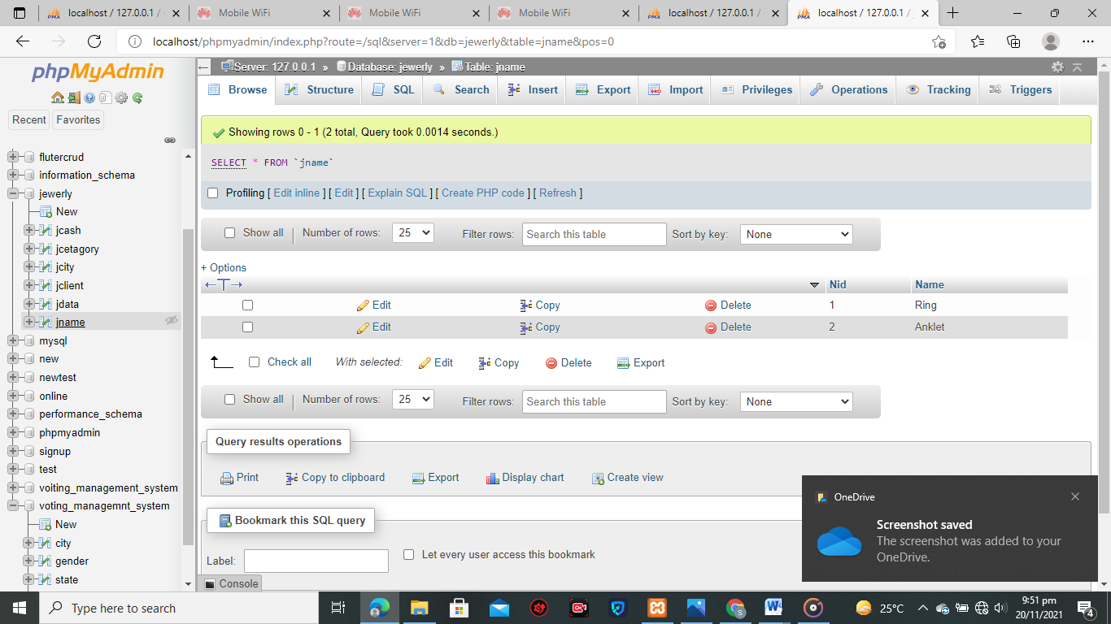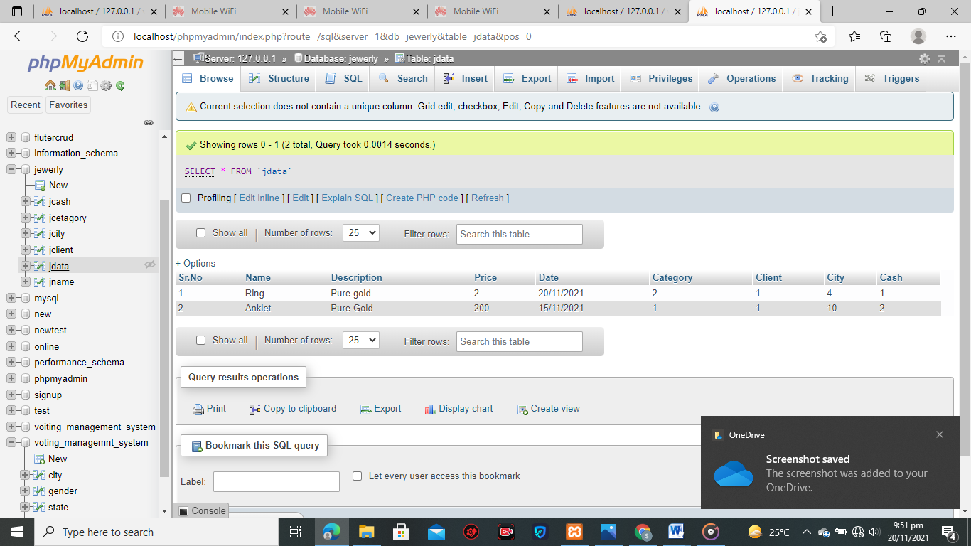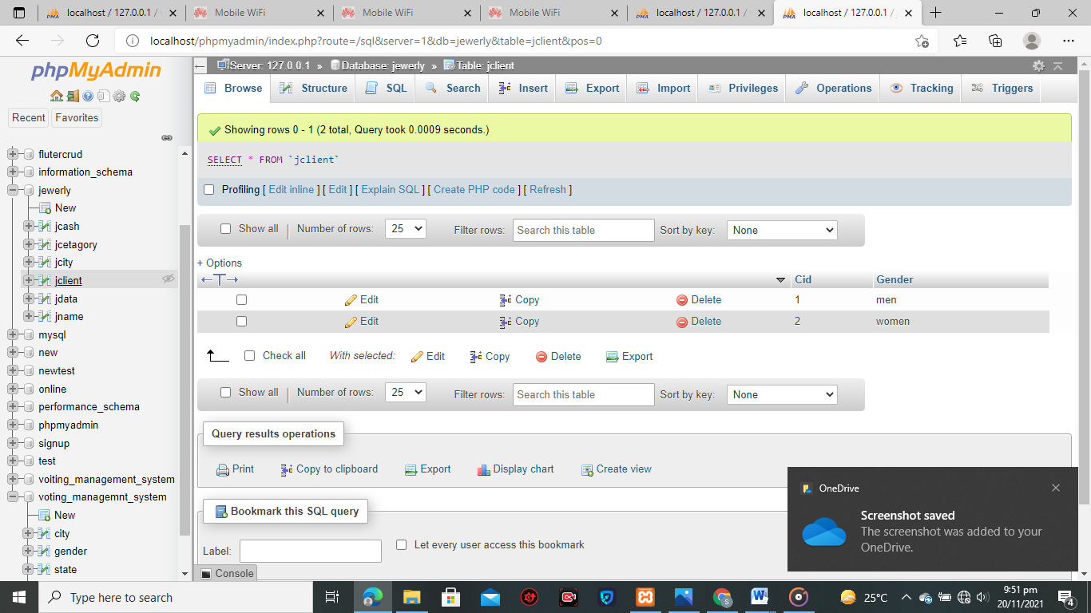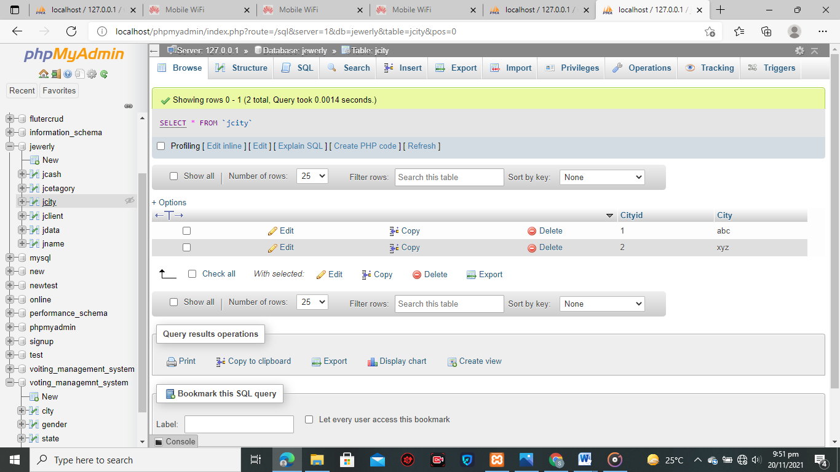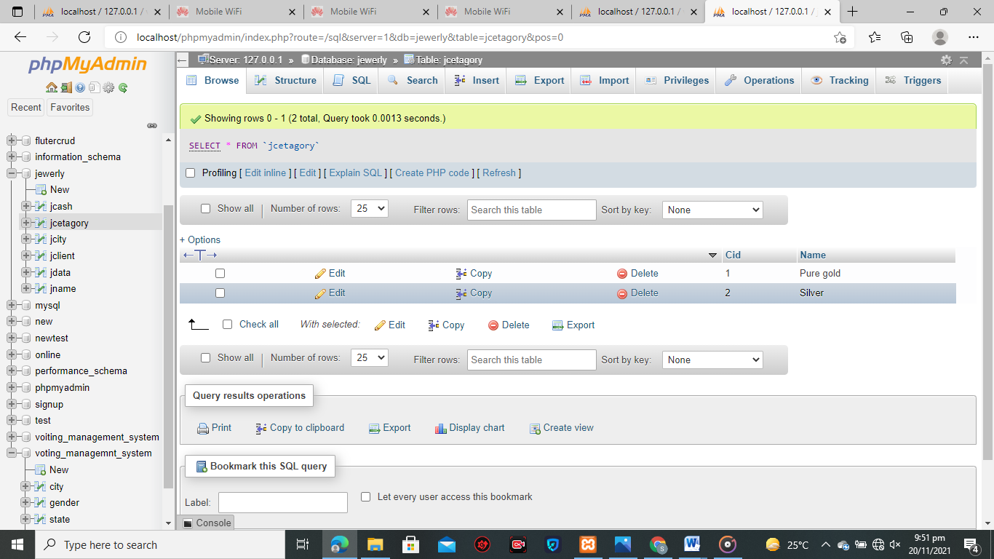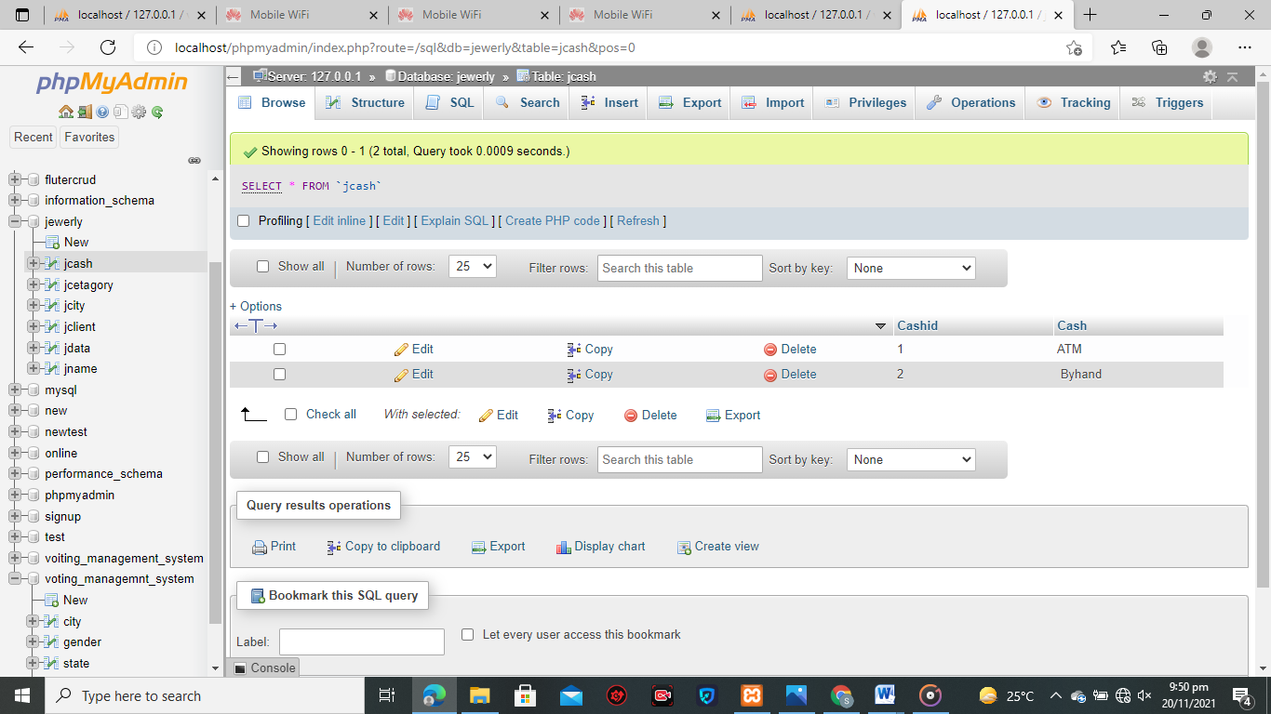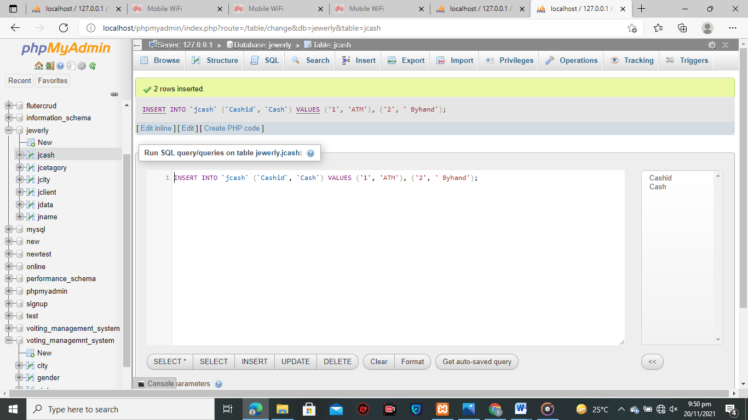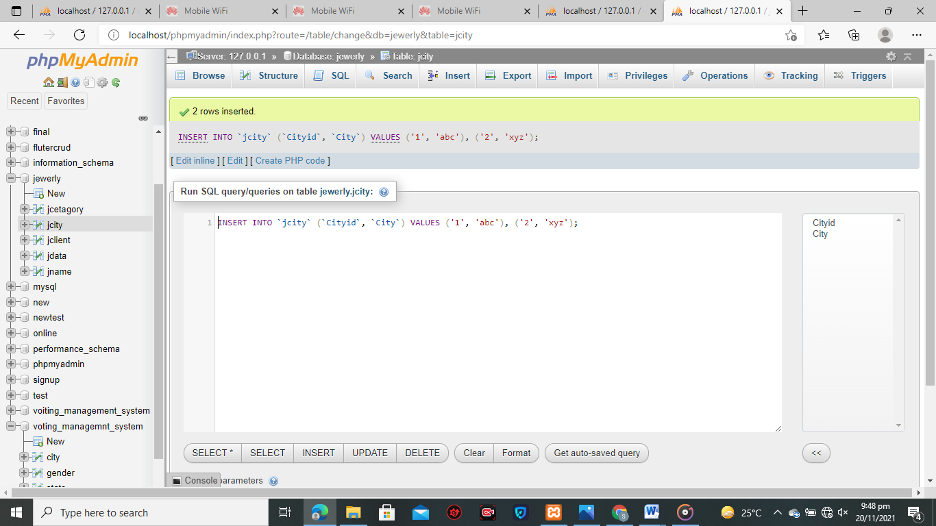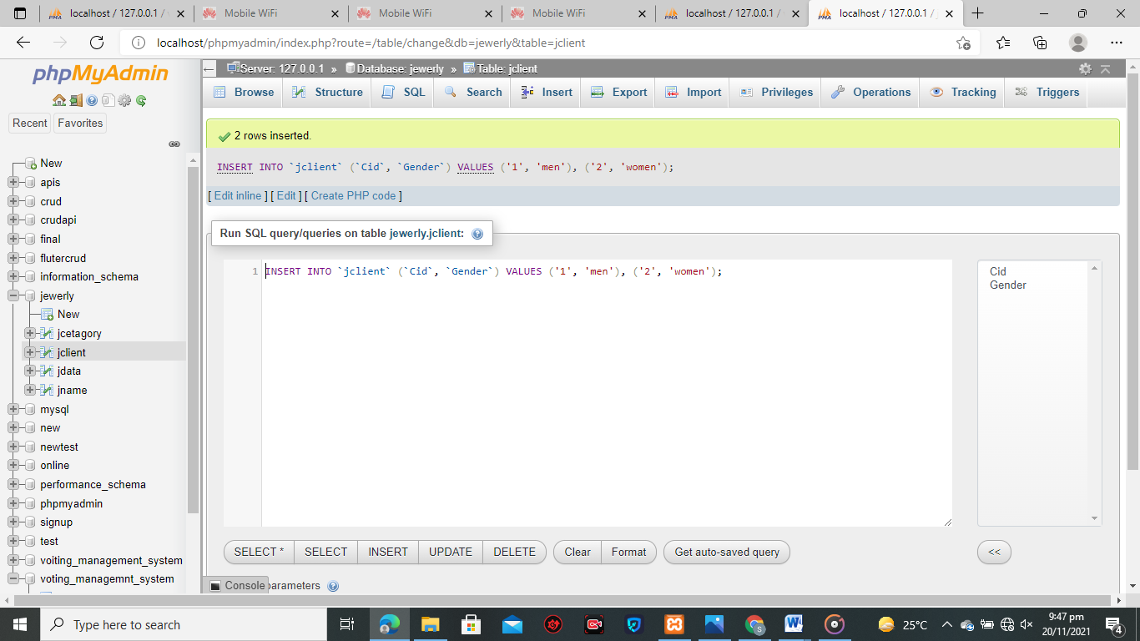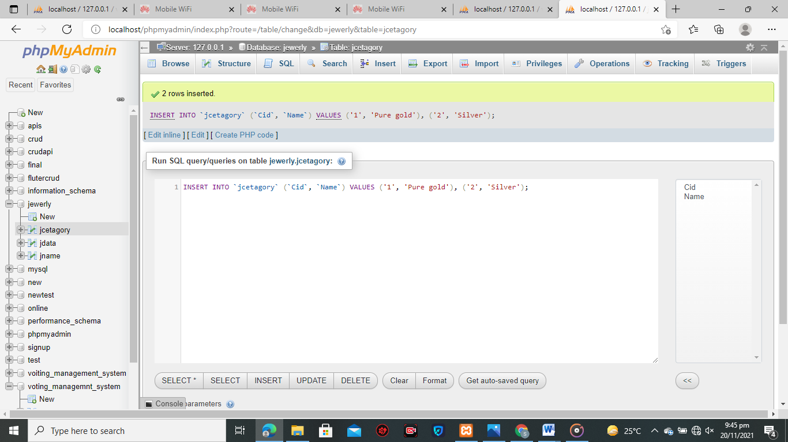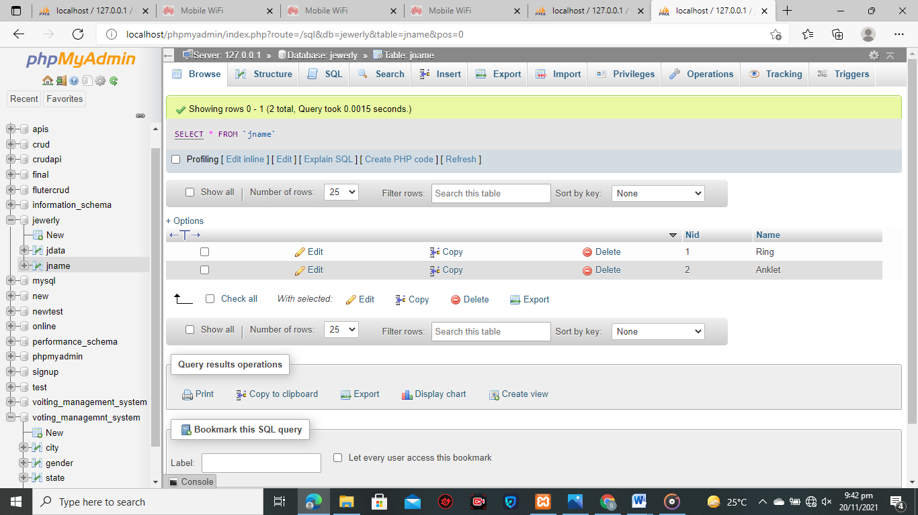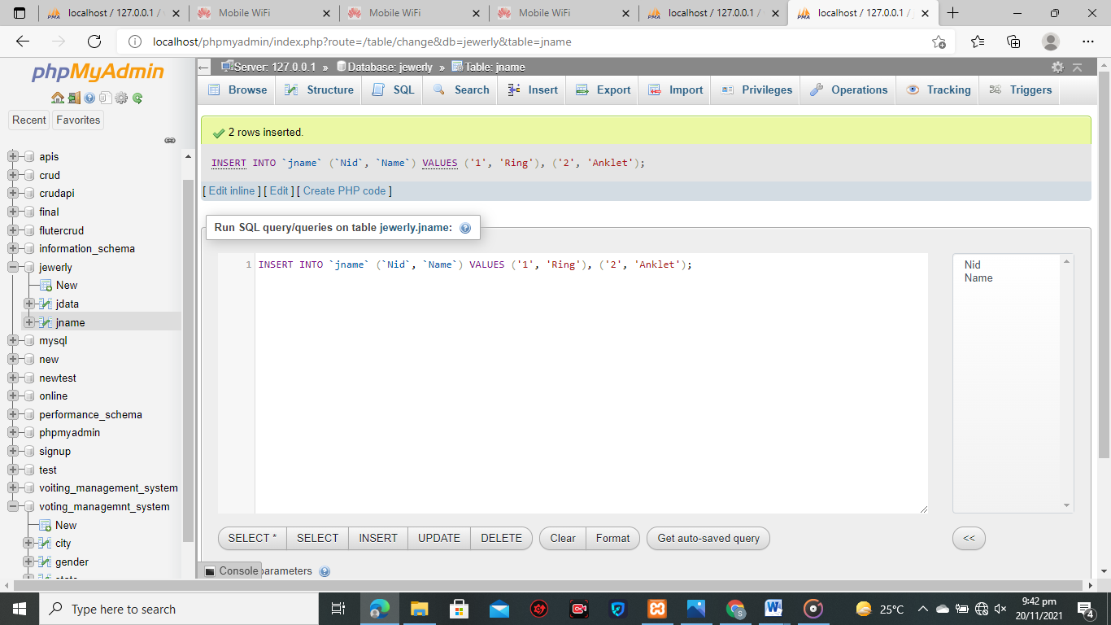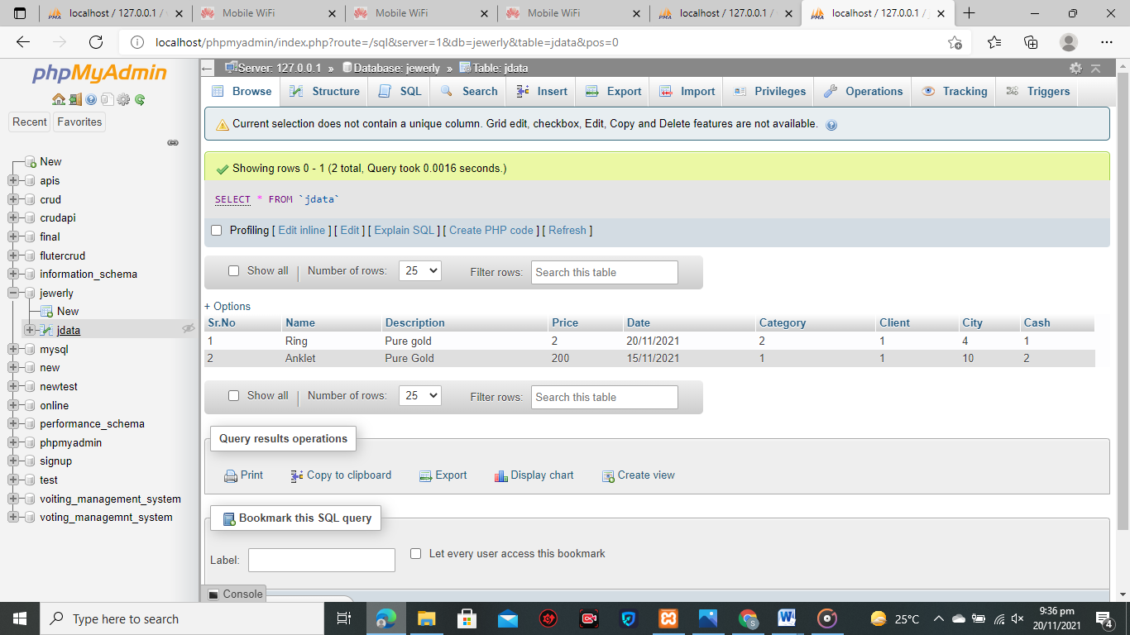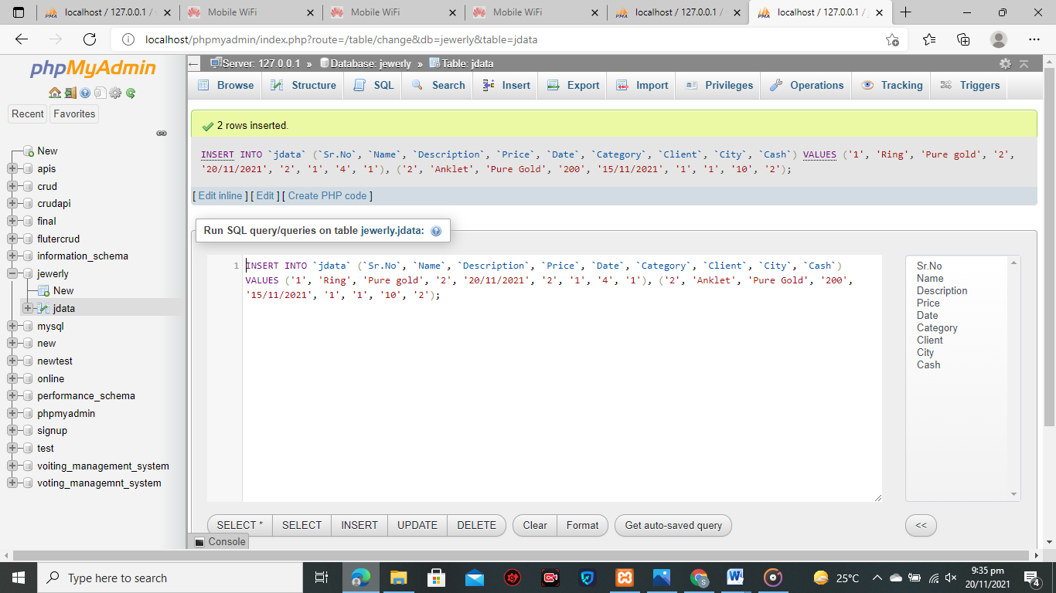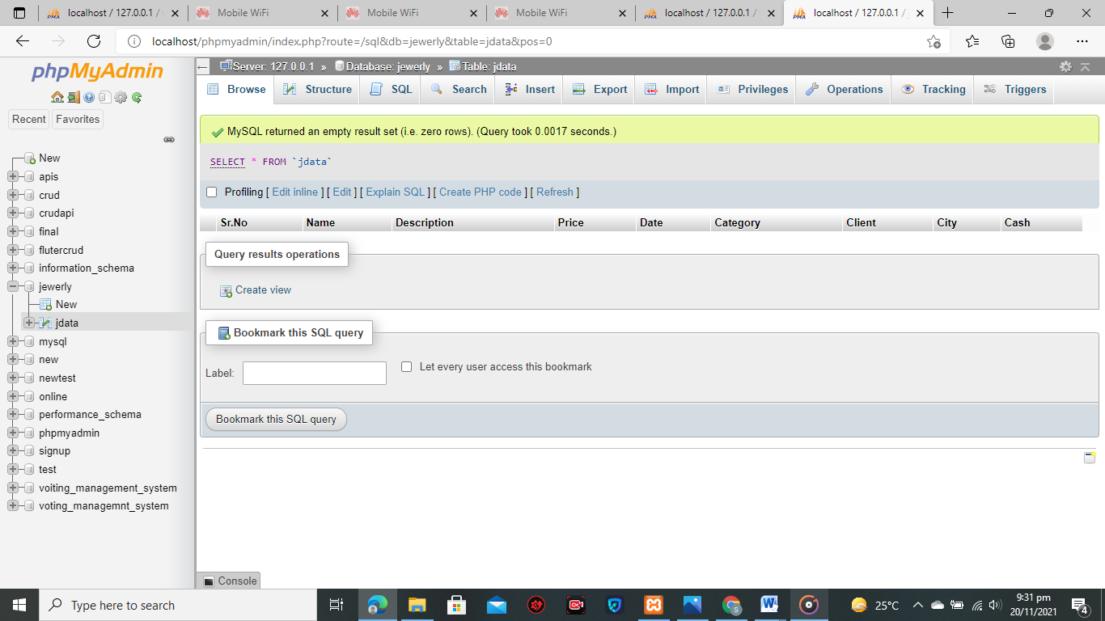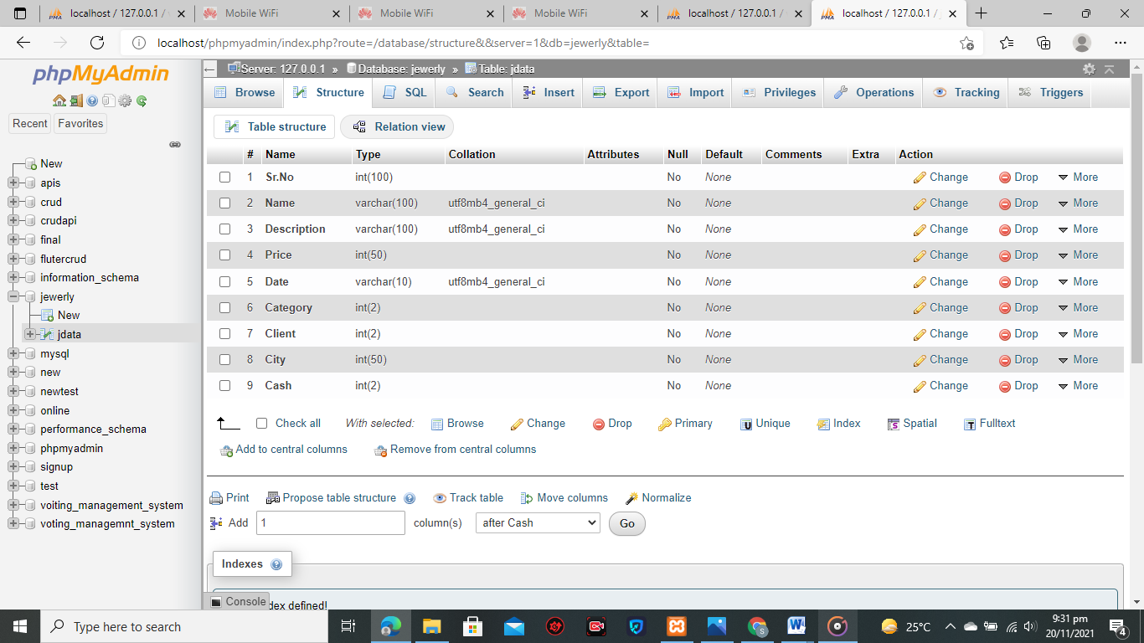

ENTER YOUR DATA SOURCES DESCRIPTION HERE

Data Storage Alternatives

*Description: We will study alternatives to storing data in a relational database. Some of the alternatives come from several decades ago, including the hierarchical and network models. Some are newer options, such as NoSQL databases that use JSON or some other encoding. Describe in detail how to store the data using two alternatives to relational databases. Be sure to describe how you would implement the alternatives and the advantages and disadvantages of each.*

*Rubric: Your work will be graded as follows*

*5 points for clearly describing how your data could be stored using one alternative to relational databases and what the advantages and disadvantages of that approach would be.*

*5 points for clearly describing how your data could be stored using another alternative to relational databases and what the advantages and disadvantages of that approach would be.*

*Total points possible: 10*

There are two Alternatives that we describe here:

**MongoDB**

MongoDB Atlas also includes powerful features to enhance reliability for your mission-critical production databases, such as continuous backups and point-in-time recovery.

**Secure from the start**

MongoDB Atlas makes it easy to control access to your database. Your database instances are deployed in a unique Virtual Private Cloud (VPC) to ensure network isolation.

**Fully automated and elastic**

MongoDB Atlas automates infrastructure provisioning, setup, and deployment so your teams can get the database resources they need, when they need them. Patches and minor version upgrades are applied automatically.

**Advantages**

MongoDB provides the facility of deep query because it supports a powerful dynamic query on documents.

It is very easy to scale.

It uses internal memory for storing working sets and this is the reason of its fast access.

**Disadvantages**

MongoDB uses high memory for data storage.

There is a limit for document size, i.e. 16mb.

There is no transaction support in MongoDB.

**FireBase Database:**

The Firebase Realtime Database is a cloud-hosted database.

Data is stored as JSON and synchronized in realtime to every connected client.

When you build cross-platform apps with our Apple platforms, Android, and JavaScript SDKs, all of your clients share one Realtime Database instance and automatically receive updates with the newest data.

**Advantages**

Reliable & Extensive Databases. ...

Fast & Safe Hosting. ...

Provides A Free Start to Newbies. ...

Google Analytics. ...

Firebase Cloud Messaging for Cross-Platform.

**Advantages**

Firebase is a great platform for developing apps, but if you’re looking to build a highly complex apps like CRM or CMS then firebase wont just do good job for you. It’s designed for super simple and realtime apps.